Shubham Rawat
MCA 2020 - 2021
Java Assignment 3
V) Programs based on Methods:
26. WAP to find factorial of a number using recursion.
import java.util.Scanner;
class factorial_reccur{
static int factorial(int n){
if(n==1)
return 1;
else
return(n*factorial(n-1));
}
public static void main(String args[]){
Scanner O = new Scanner(System.in);
System.out.print("\n Enter an No. : ");
int a = O.nextInt();
System.out.println(" Factorial of "+a+" is : "+factorial(a));

}
}
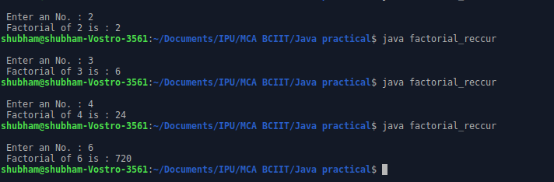

27. WAP to print the Fibonacci series using recursion.
import java.util.Scanner;
class fibonacii{
static int n1=0, n2=1, n3=0;

static void display(int n){
if(n>0){
n3 = n1 + n2;
n1 = n2;
n2 = n3;
System.out.print(" "+ n3);
display(n-1);
}

}
public static void main(String args[]){
Scanner O = new Scanner(System.in);
System.out.print("\n Enter a No. : ");
int a = O.nextInt();
System.out.print("\n "+n1+" "+n2);
display(a - 2);
}
}
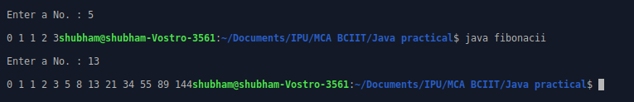

VI) Programs based on Method Overloading:
28. WAP to calculate area of rectangle, circle, square using method
Overloading.
import java.util.Scanner;
class Area_poly{
static void area(int side){
System.out.println(" Area of square side "+side+" is "+(side*side));
}
static void area(int length, int breadth){
System.out.println(" Area of rectangle of length : "+length+" and breadth : "+breadth+" is : "+(length*breadth));
}
static void area(float radius){
System.out.println(" Area of circle of radius : "+radius+" is : "+(radius*radius*3.14));
}

public static void main(String args[]){
Scanner O = new Scanner(System.in);
System.out.print("\n Choices \n 1. Area of Square \n 2. Area of rectangle \n 3. Area of Circle \n Enter your choice : ");
int a = O.nextInt();
int side,length,breadth;
float radius;
switch(a){
case 1:
System.out.print("\n Enter side of square : ");
side = O.nextInt();
area(side);
break;

case 2:
System.out.print("\n Enter length of rectangle : ");
length = O.nextInt();
System.out.print("\n Enter breadth of rectangle : ");
breadth = O.nextInt();
area(length,breadth);
break;

case 3:
System.out.print("\n Enter radius of cicle : ");
radius = O.nextFloat();
area(radius);
break;

default:
System.out.print("\n Invalid Input");

}

}
}
